CONFIDENTIAL  CS/NOV 2026/ICT450

UNIVERSITI TEKNOLOGI MARA
MARKING SCHEME

COURSE :
COURSE CODE :
EXAMINATION :
TIME :
DATABASE DESIGN AND DEVELOPMENT
ICT450
NOVEMBER 2026 (MOCK)
3 HOURS

MARKING SCHEME NOTES

- This marking scheme accompanies the ICT450 mock paper (November 2026).
Answers are unofficial model answers, not official UTM marking schemes.

- Marking points state the expected answer and the allocation of marks; every question retains its source paper and page reference.

- Five questions x 20 marks; total = 100 marks.
- Real-bank questions: 5. Placeholders: 0.
Questions and answers are for local study use only.

- Structure derived from 12 unique ICT450 past papers; every real question remains traceable to its source page.

FOR MARKERS' USE ONLY

This marking scheme consists of 6 printed pages.
MARKING GUIDE
QUESTION 1 (20 marks)
Source: ICT450-2019-DEC · page [2] · bank id ICT450-2019-DEC-Q1
Reference answer
(a) Data anomalies and big data in healthcare. [8 marks]
• i) Insertion anomaly — a new fact cannot be stored without inventing an unrelated fact; update anomaly — the same fact must be changed in several places and may become inconsistent; deletion anomaly — deleting one fact accidentally removes another.
• ii) Predictive healthcare analytics — hospital data is analysed to predict readmission risk; example: a model flags diabetic patients for follow-up.
• Population health and disease surveillance — large datasets track outbreaks and health trends; example: regional dashboards for influenza cases.
(b) How data redundancy occurs in a file system. [8 marks]
• The same customer or product data is stored in several independent files, such as an orders file and an invoices file.
• Each department maintains its own copy, so a change in one file is not reflected in the others.
• The result is wasted storage, inconsistent values and update anomalies.
(c) How referential integrity is enforced. [4 marks]
• A foreign key in the child table must either match an existing primary-key value in the parent table or be NULL.
• The DBMS rejects inserts, updates or deletes that would leave an orphan child row.
Marking guide
• a)(i) 2 marks for each of two anomalies (4).
• a)(ii) 2 marks for each healthcare application with example (4).
• b) 8 marks for a clear description of redundancy and its consequences.
• c) 4 marks for the FK rule and the DBMS enforcement action.
Provenance: model_unofficial · confidence medium · Model-authored from the approved question text, the supplied source assets and the ICT200/ICT450 knowledge base; no official ICT450 marking scheme was supplied.
Knowledge base basis: TOPIC 1 DATABASE CONCEPT (1).pdf; TOPIC 2 DATA MODEL (1).pdf; TOPIC 3 RELATIONAL DATA MODELstu.pdf
Assumptions / notes
• Figure 1.0 is answered as a generic parent-child ERD because the figure is an image crop; the referential-integrity rule is the same for any FK.

QUESTION 2 (20 marks)
Source: ICT450-2019-JUN · page [3] · bank id ICT450-2019-JUN-Q2
Reference answer
(a) Data model importance and ANSI/SPARC levels. [10 marks]
• i) A data model is a communication tool and blueprint that organises data for users, designers and programmers.
• ii) External level — the user or application view; each user sees only the data and operations needed for their task.
• Conceptual level — a community view of the whole database: entities, attributes, relationships and constraints, independent of physical storage.
• Internal level — the physical view: file organisation, indexes, storage allocation and access paths.
(b) Appropriate situations for centralized and decentralized design. [4 marks]
• Centralized design suits a single-site organisation with tight control, uniform security and moderate data volume.
• Decentralized design suits multiple branches or regions where local access, autonomy and resilience matter more than central control.
(c) DBLC stages in sequence. [6 marks]
• Database initial study.
• Database design.
• Implementation and loading.
• Testing and evaluation.
• Operation.
• Maintenance and evolution.
Marking guide
• a)(i) 2 marks for importance; (ii) 8 marks for the three levels with illustration (2 + 8 = 10).
• b) 2 marks for each appropriate situation (4).
• c) 1 mark for each of six stages in order (6).
Provenance: model_unofficial · confidence high · Model-authored from the approved question text, the supplied source assets and the ICT200/ICT450 knowledge base; no official ICT450 marking scheme was supplied.
Knowledge base basis: TOPIC 2 DATA MODEL (1).pdf; TOPIC 6 DATABASE DESIGN (1).pdf

QUESTION 3 (20 marks)
Source: ICT450-2018-JUN · page [3, 4] · bank id ICT450-2018-JUN-Q3
Reference answer
The table mixes course, tutor and student data. The student rows repeat for the course, so the data is flattened to one row per student before normalisation.
(a) Normal form of Table 1.0. [3 marks]
• The table is in first normal form (1NF) when flattened to one row per student, because each cell is atomic and a key can be formed.
• It is not in 2NF or 3NF because student data depends only on StudentID, tutor data depends on CourseCode, and TutorName depends transitively on TutorID.
(b) Dependency diagram and partial/transitive dependencies. [7 marks]
Functional dependencies.
CourseCode → CourseName, TutorID, TutorName
TutorID → TutorName
StudentID → StudentName, DOB, Gender
CourseCode, StudentID → LastAttendanceDate
Partial dependencies: CourseCode → CourseName/TutorID/TutorName and StudentID → StudentName/DOB/Gender. Transitive dependency: CourseCode → TutorID → TutorName.
(c) Normalise to 3NF. [10 marks]
1NF: one row per course-student attendance; key (CourseCode, StudentID).
2NF: remove partial dependencies into COURSE, STUDENT and ATTENDANCE.
2NF relations.
COURSE (CourseCode, CourseName, TutorID, TutorName)
STUDENT (StudentID, StudentName, DOB, Gender)
ATTENDANCE (CourseCode, StudentID, LastAttendanceDate)
3NF: remove TutorID → TutorName from COURSE.
3NF relations.
COURSE (CourseCode, CourseName, TutorID)
TUTOR (TutorID, TutorName)
STUDENT (StudentID, StudentName, DOB, Gender)
ATTENDANCE (CourseCode, StudentID, LastAttendanceDate)
3NF sample data: COURSE and TUTOR
CourseCode | CourseName | TutorID | TutorName
ICT450 | Database Design and Development | 306612 | Professor Albus Dumbledore

Marking guide
• a) 3 marks: 1NF identified, with reasons why 2NF/3NF fail.
• b) 7 marks: dependency diagram (3), partial dependencies (2), transitive dependency (2).
• c) 10 marks: 1NF (2), 2NF (4), 3NF (4).
Provenance: model_unofficial · confidence high · Model-authored from the approved question text, the supplied source assets and the ICT200/ICT450 knowledge base; no official ICT450 marking scheme was supplied.
Knowledge base basis: TOPIC 5 NORMALIZATION (1).pdf
Assumptions / notes
• The table is treated as one course with a repeating list of enrolled students.

QUESTION 4 (20 marks)
Source: ICT450-2022-FEB · page [5, 6] · bank id ICT450-2022-FEB-Q4
Reference answer
Publishing schema.
PUBLISHER (PublisherName, City, State, Country, PhoneNum)
AUTHOR (AuthorNum, AuthorName)
BOOK (ISBN, BookName, PublicationYear, AuthorNum, PublisherName)
CUSTOMER (CustNum, CustName, Street, City, State, Country, Email)
ORDER (OrderID, ISBN, CustNum, Date, Quantity)
(a) Create the BOOK table. [4 marks]
CREATE TABLE BOOK (
ISBN VARCHAR(20) NOT NULL,
BookName VARCHAR(150) NOT NULL,
PublicationYear NUMBER(4),
AuthorNum NUMBER(10),
PublisherName VARCHAR(100),
PRIMARY KEY (ISBN),
FOREIGN KEY (AuthorNum) REFERENCES AUTHOR (AuthorNum),
FOREIGN KEY (PublisherName) REFERENCES PUBLISHER (PublisherName)
);
(b) Books by John Wiley & Sons Inc and Pustaka Berhad. [4 marks]
SELECT b.ISBN, b.BookName, a.AuthorName
FROM BOOK b
JOIN AUTHOR a ON a.AuthorNum = b.AuthorNum
WHERE b.PublisherName IN ('John Wiley & Sons Inc', 'Pustaka Berhad')
ORDER BY b.BookName DESC;
(c) Books published in 2021 by Pustaka Trading in Jasin, Melaka. [4 marks]
SELECT COUNT(*) AS total_books
FROM BOOK b
JOIN PUBLISHER p ON p.PublisherName = b.PublisherName
WHERE b.PublicationYear = 2021
AND p.PublisherName = 'Pustaka Trading'
AND p.City = 'Jasin'
AND p.State = 'Melaka';
(d) Publisher that published more than 50 books. [4 marks]
SELECT PublisherName, COUNT(*) AS total_books
FROM BOOK
GROUP BY PublisherName
HAVING COUNT(*) > 50;
(e) Book name with total orders more than 3. [4 marks]
SELECT b.BookName, SUM(o.Quantity) AS total_ordered
FROM BOOK b
JOIN "ORDER" o ON o.ISBN = b.ISBN
GROUP BY b.ISBN, b.BookName
HAVING SUM(o.Quantity) > 3;
Marking guide
• a) 4 marks: columns/types (2), primary key (1), foreign keys (1).
• b) 4 marks: joins (2), IN filter (1), descending order (1).
• c) 4 marks: joins (2), year/city/state filters (2).
• d) 4 marks: GROUP BY publisher and HAVING > 50.
• e) 4 marks: join (2), SUM/GROUP BY/HAVING (2).
Provenance: model_unofficial · confidence high · Model-authored from the approved question text, the supplied source assets and the ICT200/ICT450 knowledge base; no official ICT450 marking scheme was supplied.
Knowledge base basis: TOPIC 7 SQL.pdf
Assumptions / notes
• Publisher and author names are matched exactly as printed in the schema.

QUESTION 5 (20 marks)
Source: ICT450-2023-FEB · page [6] · bank id ICT450-2023-FEB-Q5
Reference answer
The ERD models products, SKUs, colours, retailers and stores. SKU is the product-colour variant, and RETAILER_PRODUCT records the distribution contract.
(a) Construct the ERD with Crow's Foot notation. [16 marks]
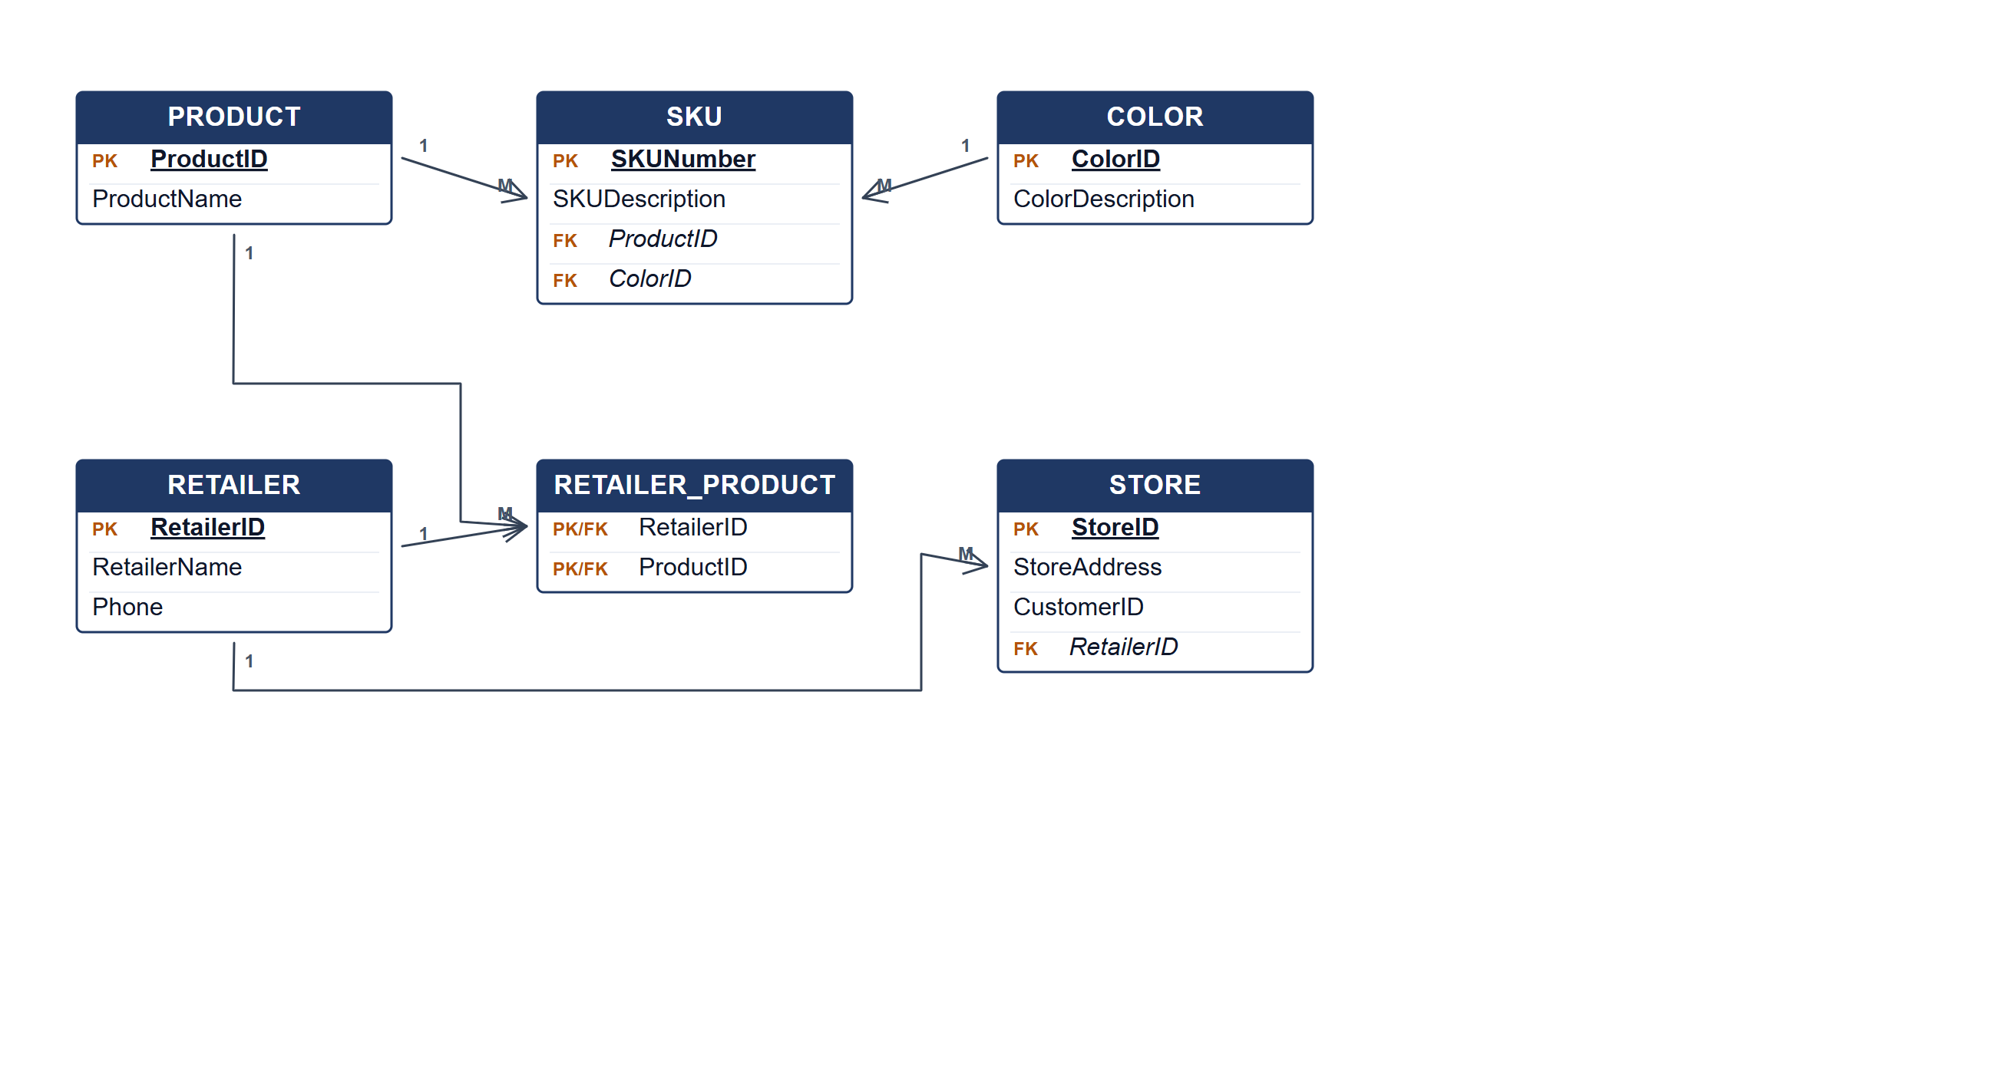
Chanteq Boutique ERD.
(b) Two reports from the ERD. [4 marks]
• Product distribution report — products and the retailers contracted to distribute them.
• SKU and colour catalogue — every SKU with its product, colour description and store availability.
Marking guide
• a) 16 marks: product/SKU/colour (5); retailer and contract (4); store and relationships (5); keys (2).
• b) 2 marks for each report (4).
Provenance: model_unofficial · confidence medium · Model-authored from the approved question text, the supplied source assets and the ICT200/ICT450 knowledge base; no official ICT450 marking scheme was supplied.
Knowledge base basis: TOPIC 4 ERD_stu (2).pdf; TOPIC 3 RELATIONAL DATA MODELstu.pdf
Assumptions / notes
• A store is identified by StoreID and carries a CustomerID for shipping confirmation; a retailer distributes many products through a contract.

